PROG6212 POE
ST10439216
Cuan Oock
Group 2
Programming 2B

PLEASE NOTE 1
GitHub Repo 2
Demonstrational YouTube video 2
Lecturer Feedback 2
References 3

PLEASE NOTE
When running the application, I occasionally needed to run it twice so that the seed data properly initializes. If login fails, please try running application again. Also the SQL file included in this submission is not needed as the program itself puts data into the database.

GitHub Repo
https://github.com/OockCuan/PROG6212POE.git

Demonstrational YouTube video
https://youtu.be/ptZxu7fDj5w

Lecturer Feedback
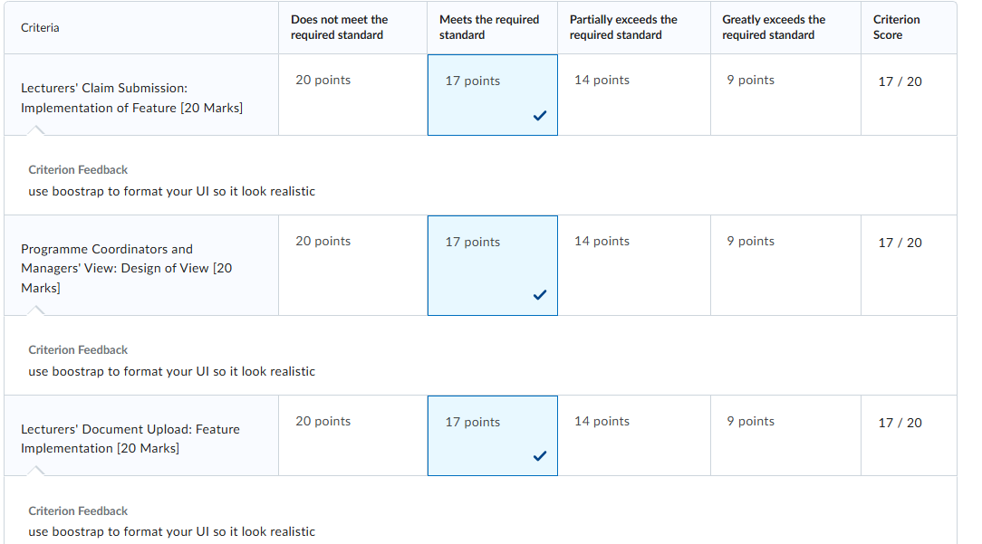
As shown above, the feedback I received was mostly to give the application a better more natural feeling through the added use of bootstrap. Although I did use some bootstrap in the POE part 2, for this part I have added even more and learnt how to integrate a very small amount of basic css, to give the home view a background image, as shown below.

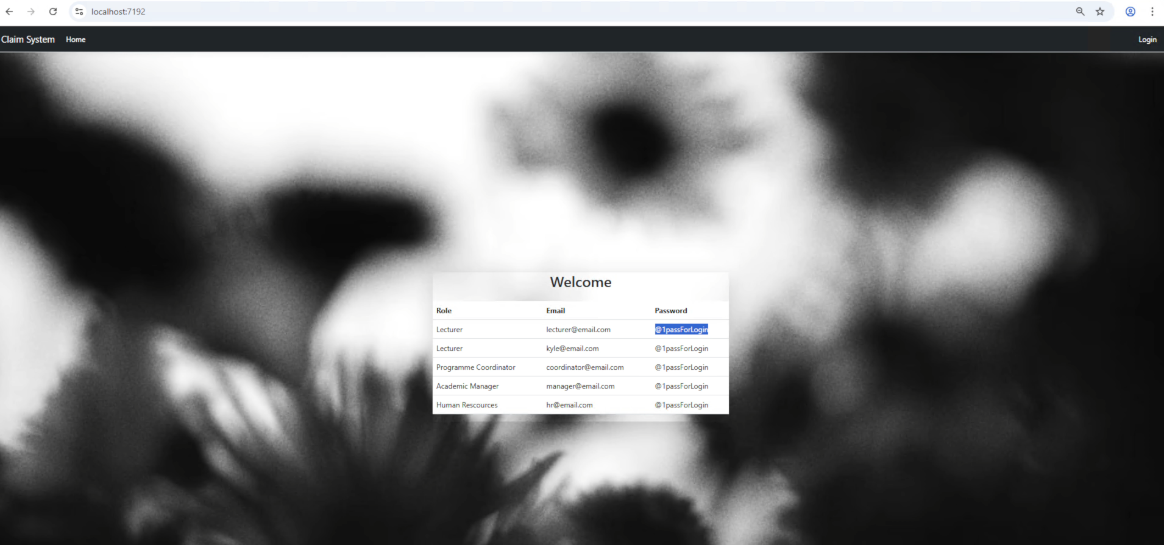
In addition, I was also given this feedback below for design choice explanation 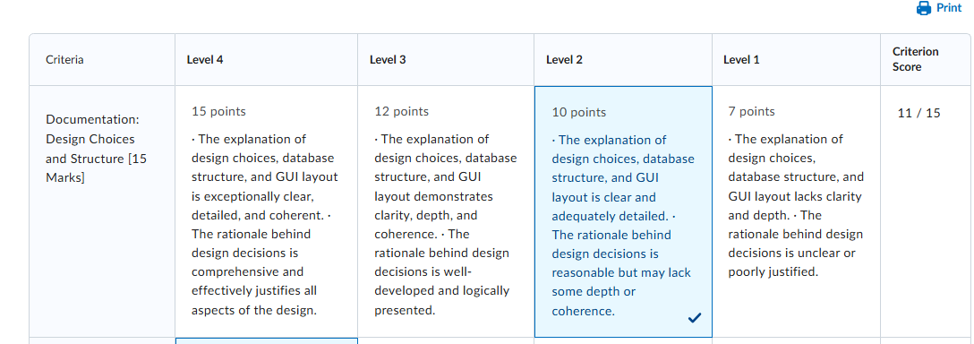
For this reason, in the presentation provided within the submission I go more in depth on choices made.

References
Mrzyglod, K. 2022. Azure for Developers: Implement rich Azure PaaS ecosystems using containers, serverless services, and storage solutions.
Toelse, A. and Japikse, P. Pro C# 9 with .NET 5 Foundational Principles and Practices in Programming. 10th ed. Apres W3schools.com. (2025).
Gido, J., Clements, JP., Baker, R., Harinarain, N., and Eresia-Eka, C. 2022. Successful Project Management in South Africa. 2nd edition. Cengage.
The IIE. 2012. Information Systems 1B [INSY6112 Module Manual]. The Independent Institute of Education: Unpublished
Dave, StackOverflow (2016). Asp.net core Identity "The INSERT statement conflicted with the FOREIGN KEY constraint ". [online] Stack Overflow. Available at: https://stackoverflow.com/questions/41280345/asp-net-core-identity-the-insert-statement-conflicted-with-the-foreign-key-cons [Accessed 21 Nov. 2025].
‌ Wilander, J. (2025). Cityscape at dusk with illuminated buildings and sunset sky. [online] Unsplash.com. Available at: https://unsplash.com/photos/cityscape-at-dusk-with-illuminated-buildings-and-sunset-sky-r_tZ7moJluA [Accessed 21 Nov. 2025].
‌ S, L. (2025). Blurred black and white flowers against bright sky. [online] Unsplash.com. Available at: https://unsplash.com/photos/blurred-black-and-white-flowers-against-bright-sky-0H8WkXxNun0 [Accessed 21 Nov. 2025].
‌ freeCodeCamp.org (2025). Stop a Page from Scrolling. [online] The freeCodeCamp Forum. Available at: https://forum.freecodecamp.org/t/stop-a-page-from-scrolling/745917 [Accessed 21 Nov. 2025].
W3schools.com. (2025). W3Schools.com. [online] Available at: https://www.w3schools.com/cssref/pr_background-image.php [Accessed 21 Nov. 2025].
‌ Trust Jamin Okpukoro (2025). CSS background image: How to add and customize it — developer guide. [online] Uploadcare Inc. Available at: https://uploadcare.com/blog/css-background-image-how-to-add-it/ [Accessed 21 Nov. 2025].
‌ Questpdf.com. (2020). QuestPDF | C# PDF Generation Library. [online] Available at: https://www.questpdf.com/ [Accessed 21 Nov. 2025].
‌

‌

